PRESSURE PRINCIPLE ACTIVITIES

CONTENTS Page
This booklet includes short utube video links for kit operation and lesson objectives
Introduction 2
Hydraulic Pump 3
Barometer 11
Submarine 12
Extensions/worksheets/etc. 14

MAKE IT! Video Link: https://desklabsllc.com
Kit supplies found in hardware, pharmacy, big chain stores or online.

WHY: Offer a visual-tactical approach to address objectives.
Simulate “cause and effect” relationships… every action, has a reaction.
Address: Next Generation Science Standards (NGSS): identify patterns, interactions,
connections, transfer of energy, change, etc. Examples: MS-PS1-4; MS-PS2-2:
MS-PS3-4/5; HS-PS1-5; HS-PS2-1/2; HS-PS3-1/4
Science, Technology, Engineering, Mathematics (STEM): investigations promote
inquiry, critical thinking, and problem solving analysis

WHAT: Self-made science kit used for demonstrations and/or student projects.

WHO: Presented by a teacher or a student.

WHEN: Introduce a new science concept, engage students in interactive lessons, promote project ideas.

WHERE: Simulations are designed for classroom projection systems, lab table activities, or home projects.

HOW: Experiment with self-made science kits/models

Scientific principles and laws related to pressure…

- Pascal’s Principle: equalizing pressure. A change in pressure in an enclosed fluid will
be transmitted equally to all parts of that fluid. Air/water (“fluids”) move through the system
until chamber and ballast air/water pressure reach an equilibrium.
- Charles’s Law: temperature affects volume. At constant pressure, the volume of gas
increases as the temperature increases and vice versa. Example: if an air chamber heats
up, the expanding air will move into a connected air chamber. If air chamber cools down,
contracting air will reverse the process.
- Boyle’s Law: pressure affects volume. At constant temperature, the volume of gas
decreases as pressure increases or vice versa. Air volume decreases with depth.
Archimedes’ Principle: volume affects buoyancy. Buoyancy of an object in fluid is equal
to the weight of the volume of fluid that the object displaces. Changing ballast tank air volume, changes amount of water displaced. An object with higher density than water has less
buoyancy and sinks. An object with a lower density than water floats.
- Newton’s Laws: First Law: A body continues to maintain its state of rest or of uniform
motion unless acted upon by an external unbalanced force. Third Law: “To every action there
is an equal and opposite reaction”.
2.

Fluid Pressure

Hydraulic Pump

Make it…
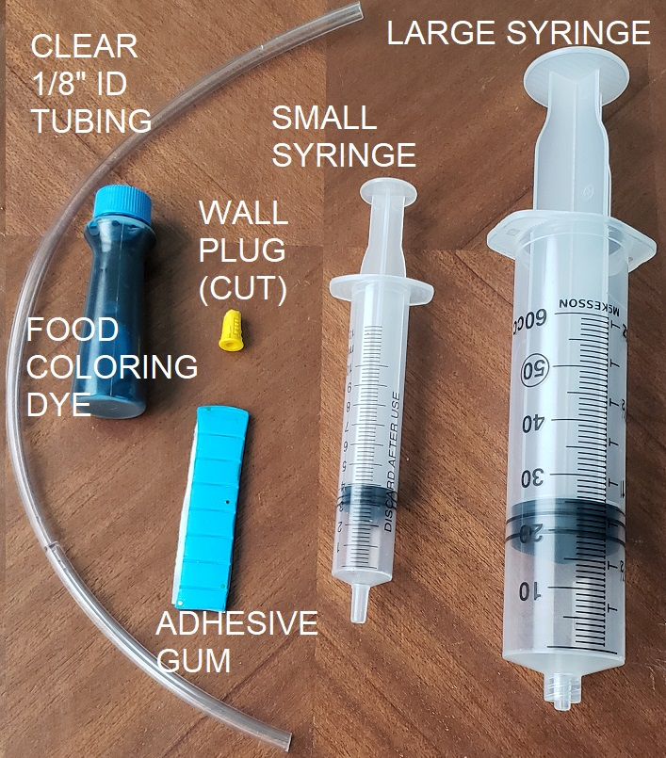

Hydraulic “pump” kit illustrates how fluid pressure

is used to lift vehicles, move dozer blades, stop

cars, and fracture rock (gas/oil process).

Hydraulic Pump Supplies: 1/8th “ID clear

tubing (12”), large syringe, small syringe, food

coloring dye, adhesive gum, plastic wall plug (cut).

HYDRAULIC PUMP

Assembly instructions (photo): connect clear tubing

section to a small syringe. Fill syringe with colored

water (“oil”), connect the opposite end to large

syringe. Place on template as directed. Secure

syringe to the template with tape or adhesive gum.

Push syringe plunger in to “pump” “oil”. It causes

other syringe plunger to extend outward.

Note: Overhead projection works better with a low

volume of colored water in the syringe chamber.

Refer to Pascal’s Principle on “equalizing fluids”, p.2.

- Hydraulic Lift System

Video Link: https://youtu.be/zWOjtUS9fsM

Set-up

Make a copy and/or transparency of Lift template (next page). Follow instructions in Fig. 2. Secure both syringes to template. Test plunger “piston” range and operation.

Worksheet Lift Activity
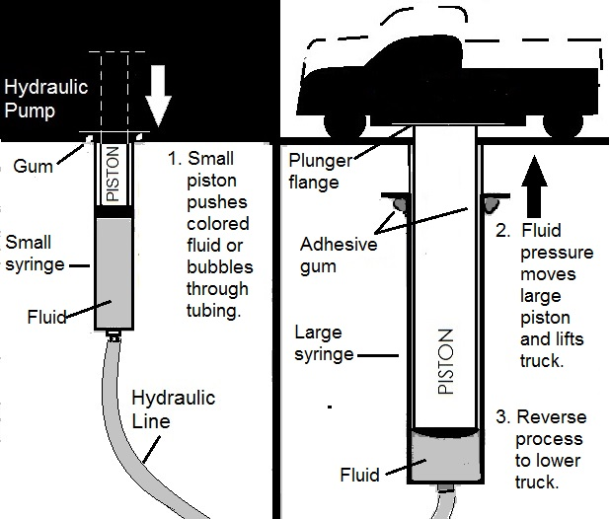
Fig. 2

Example: sketch lift system and parts.

Use numbered captions, labels,

and. arrows to show process/operation.

Relate to Pascal’s Principle, p. 2.
Fig. 1
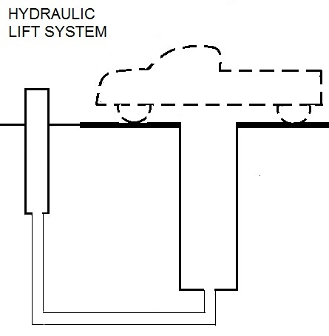

3.

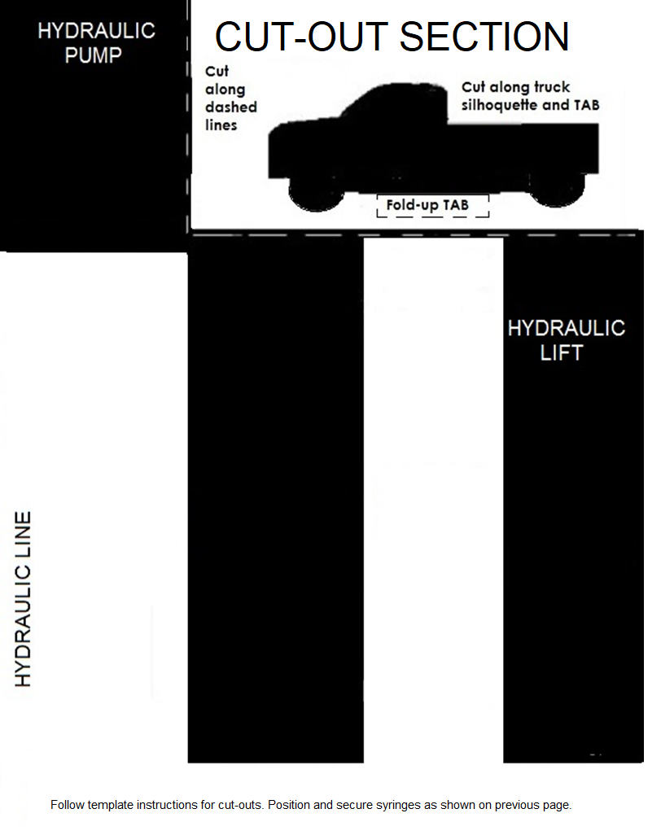

4.

2. Hydraulic Brake System
Fig. 1

Video link https://youtu.be/r7JAgGjg-2A
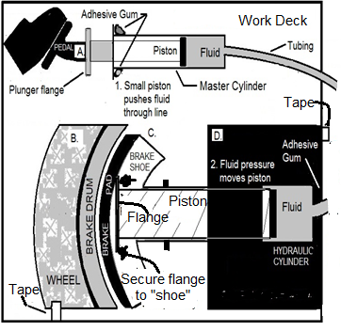

Set-up

-Make a copy and/or transparency

of Brake template next page and

follow instructions in Figure 1.

-Arrange template sections “B” &

“D”, so that plunger “pistons” have

proper range to show braking action.

Use adhesive gum to anchor syringes

& cut-outs.

Worksheet Brake Activity

Example: refer to Fig. 2.

Number each step and use letters in drawing

to explain how the brake system operates.

Label parts. Refer to Pascal’s Principle.

Fig. 2
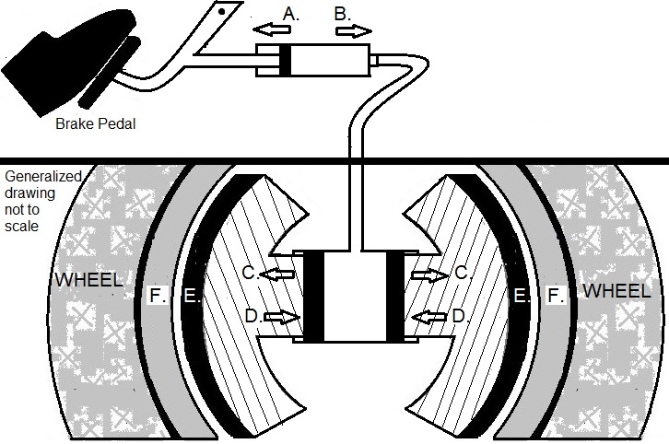

4.

5.

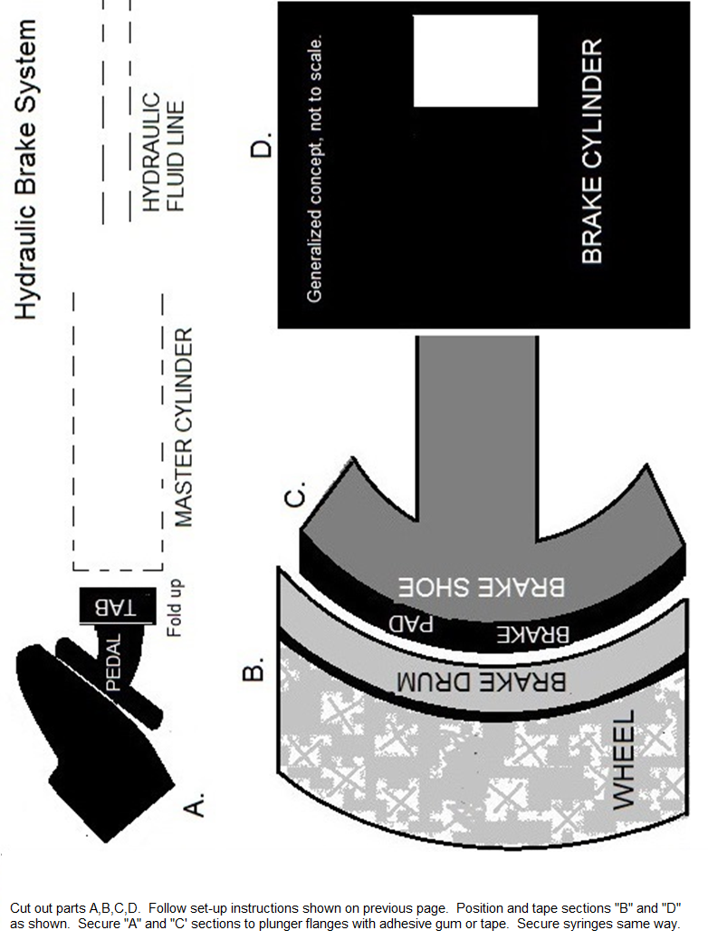

6.

3. Hydraulic Dozer Blade System

Video link https://youtu.be/nUy1HNlH2CY

Fig. 1

Set-up
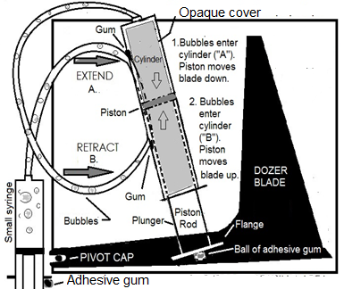

Make a copy and/or transparency

of Dozer Blade template on next

page and follow instructions in Fig. 1.

Create bubbles in small syringe

by drawing in water/air.

Set and test plunger positions to

extend-retract blade.

Anchor syringes and plunger

flange with tape or adhesive gum.

Worksheet Blade Activity

Example: Fig. 2

Use numbered steps to explain

how the brake system operates.

Label parts. Identify steps using

letters in drawing. Refer to

Pascal’s principle.

Relate activity to other similar

operations (i.e. backhoe, crane,

forklift, etc.).

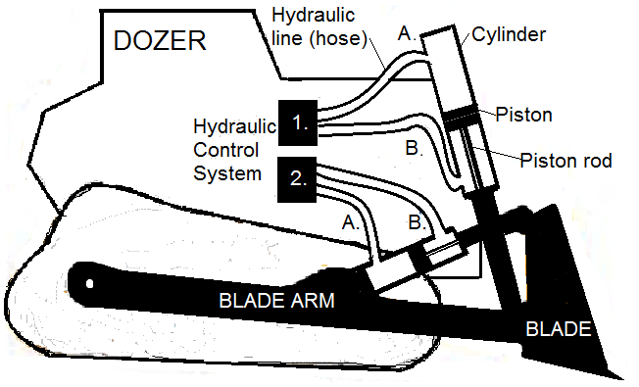
Fig. 2

7.
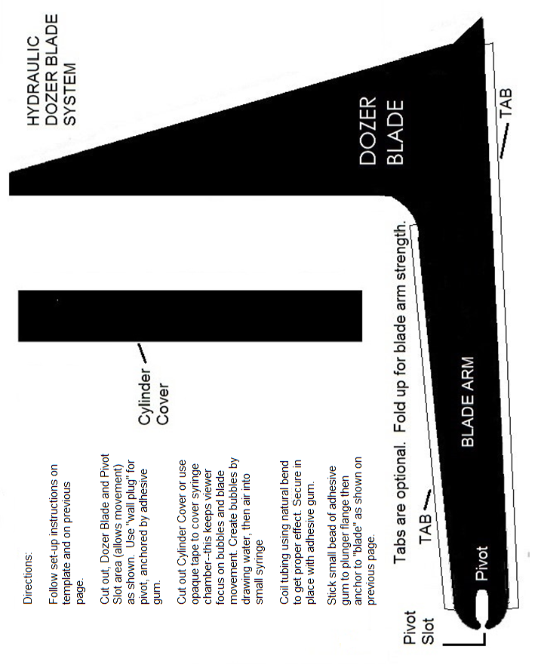

8.

4. Hydraulic Fracturing (“Fracking”)

Video link: https://youtu.be/E_aY2bjwAFo
Fig. 1

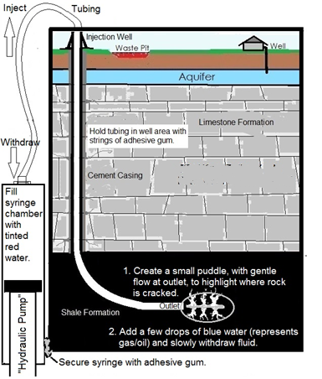

Set-up

Make a template transparency (or use a

transparency for water protection) of the

Fracturing template on next page.

Follow Fig. 1 instructions.

Place syringe on work deck and

anchor it with adhesive gum.

Place natural bend of tubing on “drill

well” curve and hold it in place with

strings of adhesive gum (roll it with

fingers) or with clear tape.

Fill two small containers with water.

Add red dye (injection fluid) to one and

blue dye (oil/gas) to the other. Red dye

water represents pressurized fluid,

chemicals, and sand.

Draw red water inro large syringe.

Test plunger range-- inject and then

withdraw fluid puddle created on

transparency sheet.

Lesson:

Inject red dye to create a small puddle

on transparency (Fig. 1).

Add a few blue dye drops to puddle.

Slowly pull plunger outward to draw in
Fig. 2

blue puddle—represents retrieving

gas/oil escaping from fractured shale.
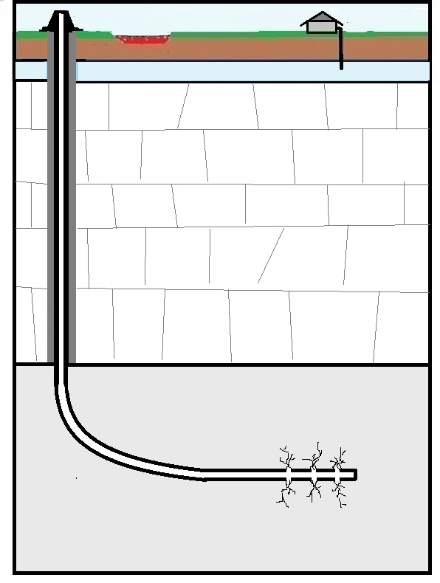

Clean up: place a paper towel in remaining

tubing outlet puddle to wipe up and to purge

fluid from line.

Worksheet Fracturing Activity

Example (Fig. 2):

Describe operation and function of hydraulic

fracturing. Use numbered captions, arrows,

and labels.

Note: Generalized drawing not to scale.

Discuss pros and cons of “fracking”.

Consider situations related to mining

non-renewable resources, broken well

pipe casings leaking waste pits, tremors,

and contaminated aquifers.

Refer to Pascal’s principle.

9.

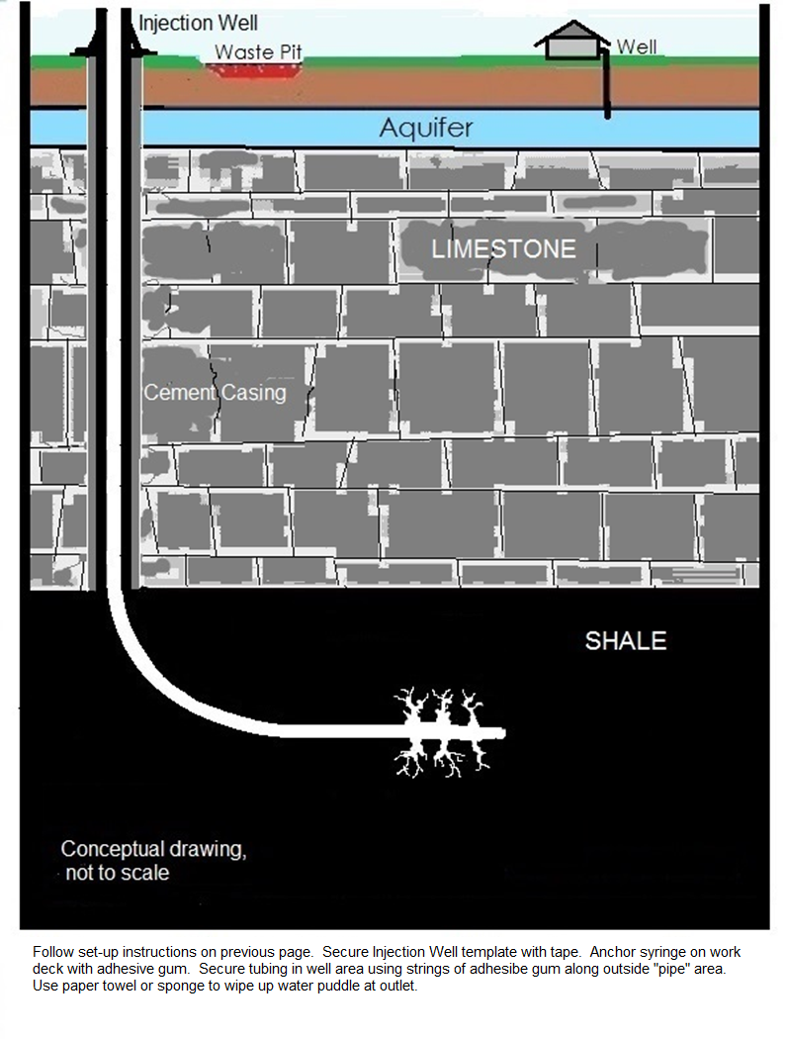

10.

AIR PRESSURE
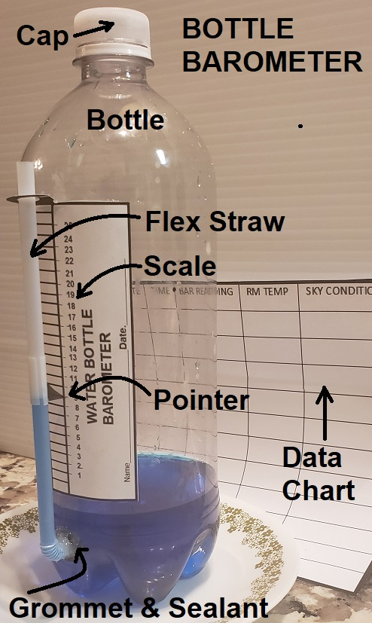
Barometer
Make it…
PLASTIC BOTTLE BAROMETER

Barometer Supplies: clear plastic bottle with cap, grommet,
100% silicone sealant, clear flexible straw, food coloring dye.
Fig. 1
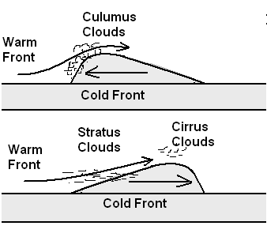
WATER BOTTLE BAROMETER
-Assembly: Fig. 3 & Fig. 4 & photo.
-Drill straw hole to fit grommet hub
(if 1/4” grommet hole=3/8” drill bit).
-Modify “scale” (Fig. 4) to fit bottle.
-Insert transparent flexible straw in
grommet & apply sealant to area.
-Add colored water to bottle--just
above straw inlet.
-Chart (Fig. 2). Record data at least twice a day. Place barometer in
area where the temperature is constant (away from heat source).
Fig.4
Lesson Concept: a change in air pressure is used to predict weather.
Barometers respond to high air pressure (clearer sky) and low air
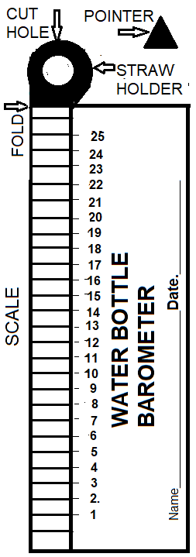
pressure (cloudier sky). Refer to Fig 1. High air pressure (cool dense air)
“pushes” straw water downward. Low air pressure (warm less-dense
air) causes straw water to rise.

START: Slide “pointer” to straw water level scale position. Observe daily
change(s) in straw water level (up/down). Relate to weather predictions,
intense storms, etc. Note: use overflow drip dish (for low pressure days).
Fig. 2
DATE | TIME | BAR READING | RM TEMP | SKY CONDITIONS

Fig. 3
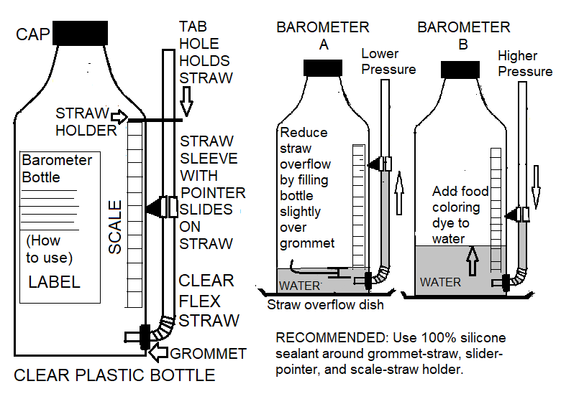

11.

Air Pressure
Submarine
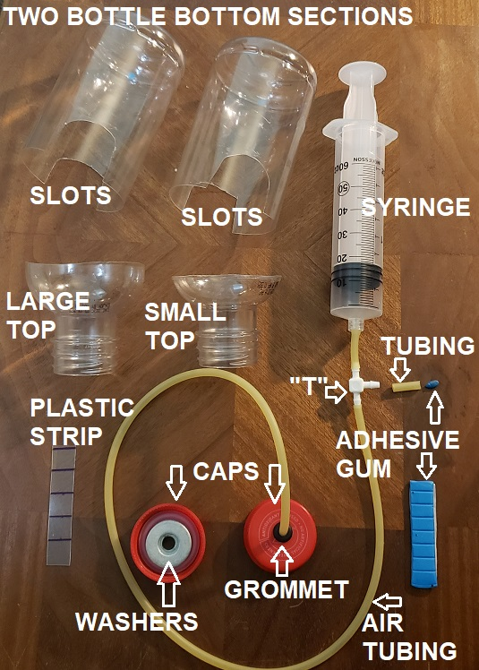
Make it…
PLASTIC BOTTLE SUBMARINE
Video Link: https://youtu.be/KAj-OPrYPgY

Submarine Supplies: Syringe (other options: flex straw
or aquarium air pump); small aquarium; two small clear plastic
bottles (20 fl. oz or less) with caps; 2’-3’ latex tubing (or clear
tubing); grommet; “T” connector; washers or pennies (10);
100% clear silicon sealant; “T” cap (tube piece with adhesive
gum plug or silicone sealant plug).
Fig. 1
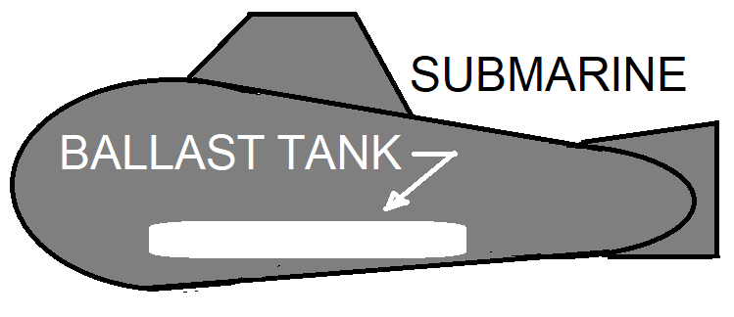

WATER BOTTLE BAROMETER.
Use clear bottles with few ridges.
Cut ballast tank “scale” from
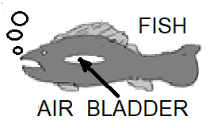
bottle waste section or a piece of
transparency (Fig. 2, Fig. 3).
Important: ballast tank volume
should be close to syringe chamber
volume to get full up/down range.
Fig. 2

Dive, hover, surface:
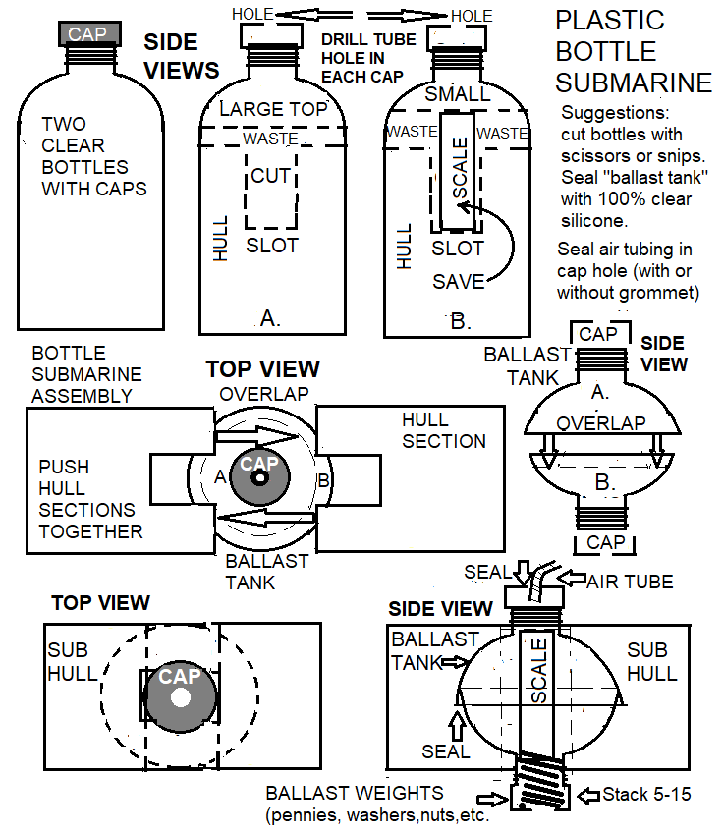

Adding ballast tank air will

cause submerged submarine

to rise—similar to a fish’s

bladder (Fig. 1).

Refer to relationships of

volume, pressure and

temperature to density p.2.
Fig. 3

Suggestion:

Glue
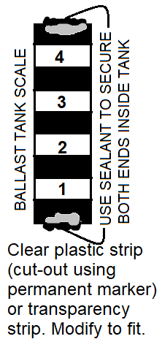

“scale”

inside

ballast

tank.

Use it

to

record

ballast

tank

water

level

at each

depth.

Investigations:

Refer to volume and

temperature ideas on

the next page.

12.

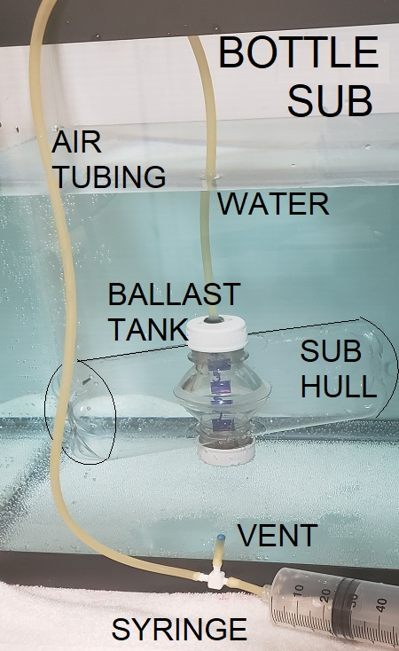
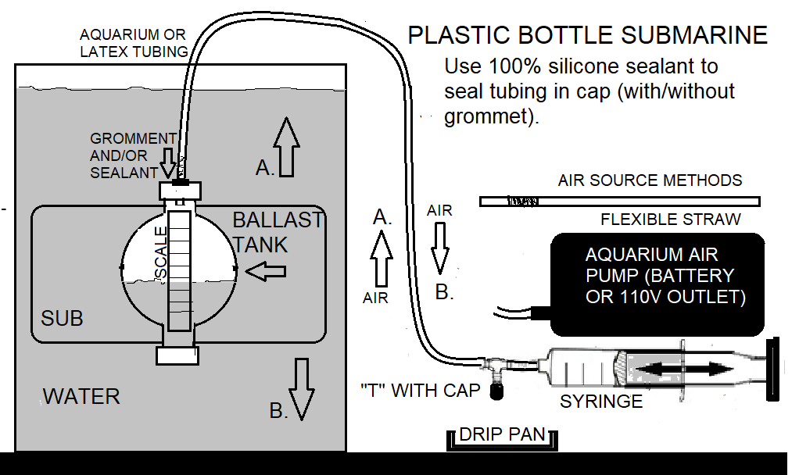

INVESTIGATION IDEAS

Design investigations that involve changes in volume, temperature and pressure as they relate to density.

INVESTIGATION  OBJECTIVE | CONTROL VARIABLE  “no change” | INDEPENDENT VARIABLE  “one change” | DEPENDENTVARIABLE  “responds to change”
Determine what will happen to submarine’s depth when ballast tank air volume is changed | Water density, air temperature, weight, submarine starting depth | Ballast tank air volume | Submarine depth

INVESTIGATION  OBJECTIVE | CONTROL VARIABLE  “no change” | INDEPENDENT VARIABLE  “one change” | DEPENDENT VARIABLE  “responds to change”
Determine what will happen to submarine depth if air system temperature changes. | Water density, ballast tank air volume, weight, starting depth, starting temperature | Air system temperature | Submarine depth

Use charts and graphs to collect and organize data. Record depth, weight, &volume data with trials that include using fresh and salt water, light and heavy ballast, etc.

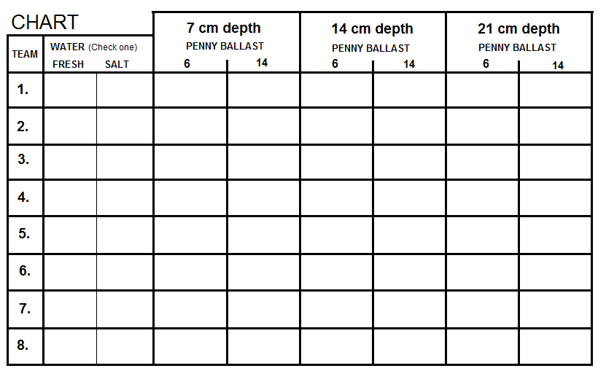
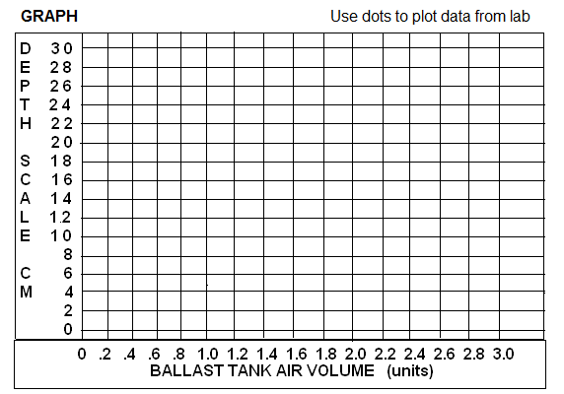

13.

EXTENSIONS/ENRICHMENTS
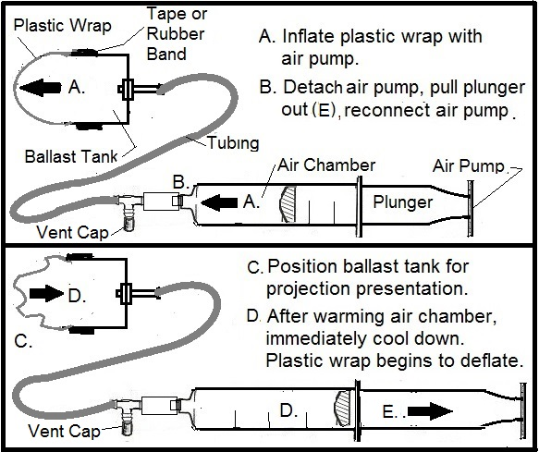

Investigate other uses for the “pump” concept. Create

working models that show how pressure differences are

found in everyday life.
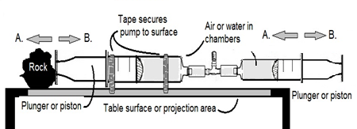

Submersible Invention
Design an underwater vehicle that is capable of drilling, scrapping, vacuuming, etc. valuable
minerals off the sea floor. Include labels in your craft diagram with essential equipment/tools needed
to do a sea floor mission. In particular, show the ballast tank system and explain how it works.
Consider designs used on land-based construction equipment (bull-dozer, excavators, etc.)
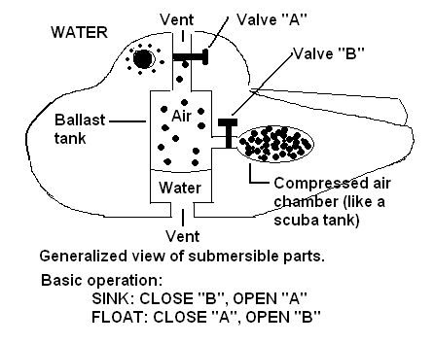
Color code each major compartment:

1. Living quarters, communication system, and life
support systems (fresh air, carbon dioxide
removal, water, etc.) color green.
2. Propulsion system (motor, batteries, propellers,
tracks), steering system color red
3. Mechanical arms(s), lights, portholes, ballast
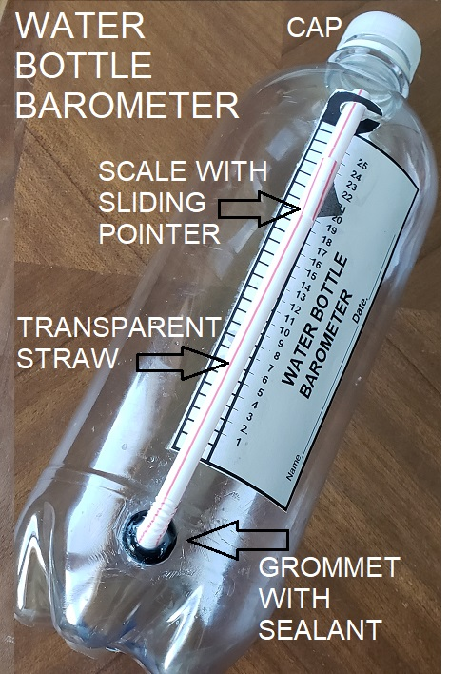
tank(s), other equipment color yellow.

Research Projects
- Atmospheric pressure (i.e. weather, hot air balloons, climbing, cooking in mountains).
- Surface tension (bugs, leaves, etc. floating on water)
- Submersibles used for deep sea exploration (ocean oil drilling, diamond mining in shelf deltas,
and manganese mining on Abyssal Plains).

Science Method
Terms and concepts for lab activities and evaluations:
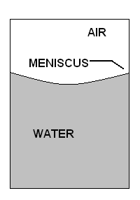
- Variables: Control: part of the experiment kept the same. Independent=
one change by scientist (action), Dependent=depends on independent
(reaction).
- Surface tension: it is more difficult for an object to move into a liquid
than move through it because the fewer surface molecules have a
stronger bond than the many interior molecules that are bonded in
all directions.
- Meniscus: curved surface of a liquid occurs when molecules of a liquid

attract the molecules of the container. Refer to drawing (right).
- Measurements: decimals, metric scale, mass, weight, density, specific gravity, etc.
- Compare hypothesis (educated guess) and theory (facts that prove hypothesis).

Resources Search
. Create an aquarium sea floor scene using sand. Lightly cover colored paper clips in patterns.
Replace ballast tank with a mini-super magnet. Assign students an area to search as they lower
submarine to “sea floor’. Instruct students to retrieve ”ocean deposits” only in their area. Use
coded deposit samples to fill out a grid and predict mineral resource areas.
14.

WORKSHEET
1. Is air pressure in the basketball and the air
chamber the same or different? Explain.

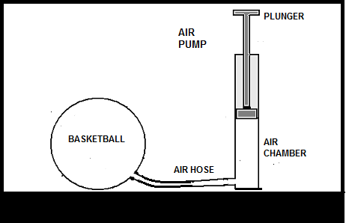
2. Which fish appears to be swimming at a greater depth?
Explain.

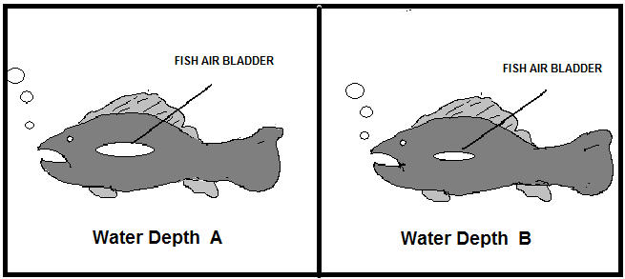

3. Balloon position “B” is moved to position “A” .
Explain size change. Do the same for position “C”.

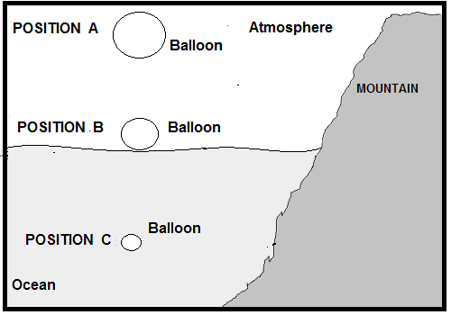
4. What happened to the balloon between day time
and night time? Explain.

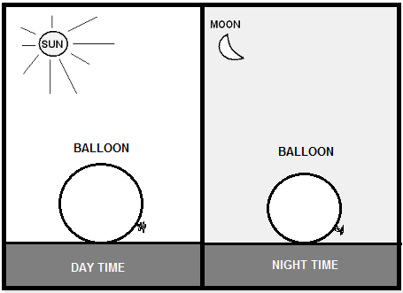

6. Do you inhale or exhale when
your diaphragm muscle relaxes
at position A?
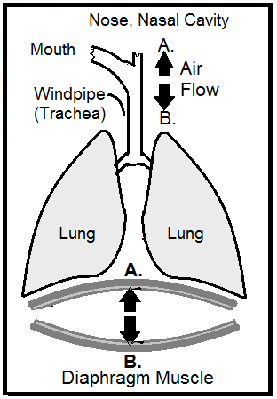

5. Which balloon (A, B) best illustrates inflated balloon? Explain.

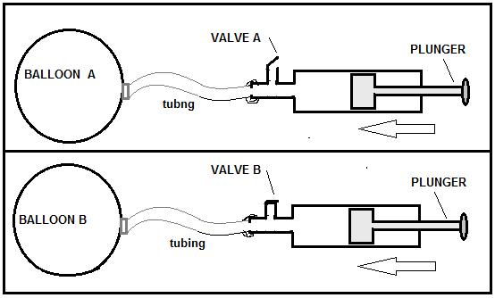

7. Your eardrum may experience a change
in air pressure on an airplane. What
body system helps balance outer ear
and inner ear air pressure?
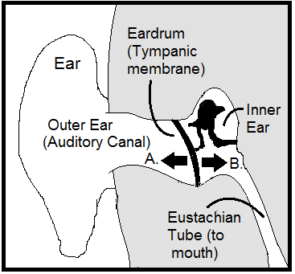
8. Which barometer (A, B) appears to show approaching storm?
Explain. Hint: high air pressure brings clear, cooler skies; low air
pressure brings cloudy, warmer skies.

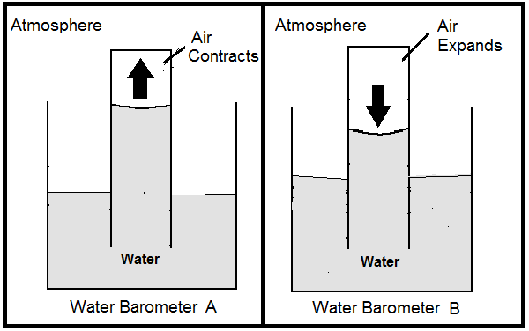

15.

9. If handle on hydraulic pump is pushed downward
what happens to the rock? Explain.

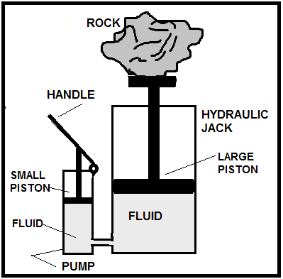
10. Fig. 1. Which hydraulic line (A or B) retracts
piston? Explain.
Fig. 2. Which hydraulic line (A or B) extends
piston? Explain.

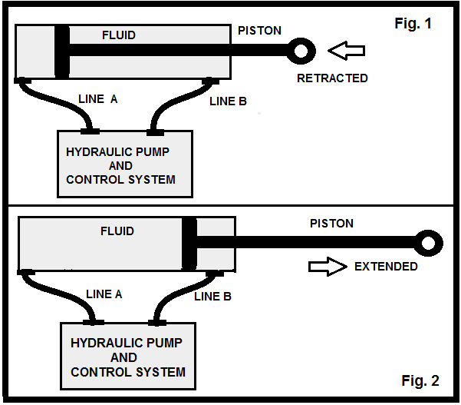

11. Hydraulic pistons A & B have dozer blade in down
position. In # 10, which Figure (1, 2?), correctly
represents lifting both blade pistons? Explain.

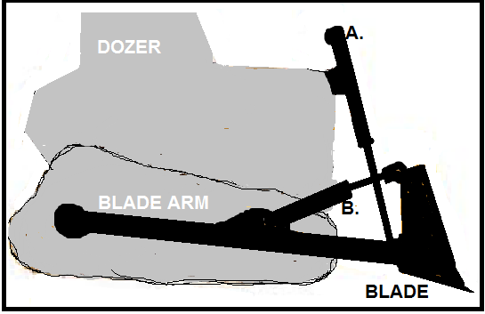

12. What needs to happen to pull dirt into intake?

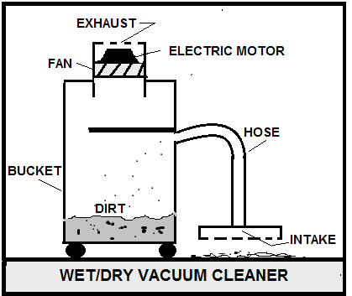

13. Fig. 1. Which outlet has greatest water pressure. Explain.
Fig. 2. Properly sequence houses according to those that have
highest water pressure to those with lowest water pressure.

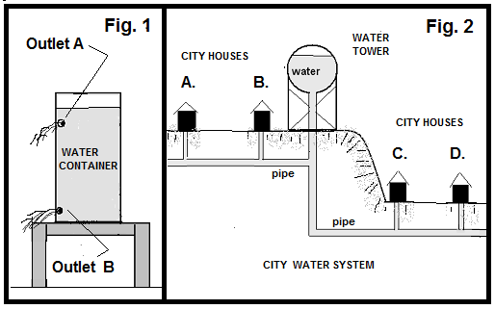

14. Fig. 1. Is it possible to have water in the straw
higher than water in the container? Explain.
Fig. 2. Which tubing (A, B), best illustrates
siphon function? Explain.

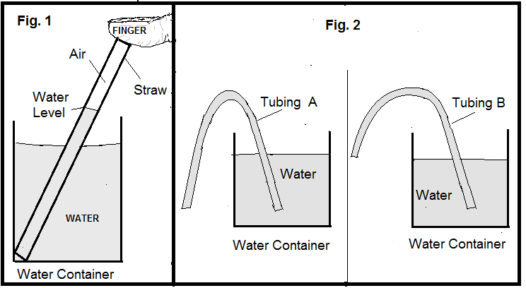

111
15. Which ship is likely located in fresh water, not salt
water? Explain.

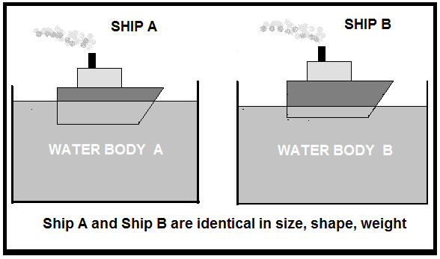
16. Continental and ocean crust “floats” on the earth’s
mantle. Explain concept by comparing the density of
crust rock to the density of mantle rock.

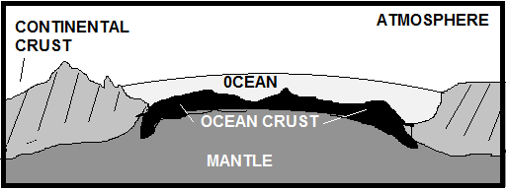

16.

REFERENCE
Illustrations: Dots refer to air particles. Answers: Use this Reference and other resource material to answer worksheet questions.
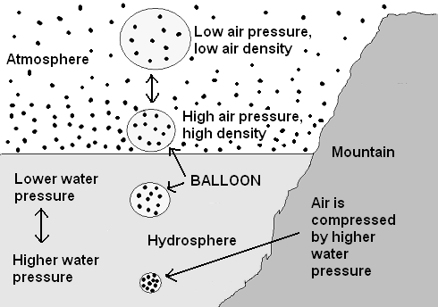
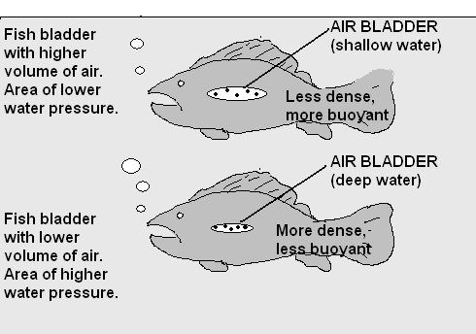

1.
2.

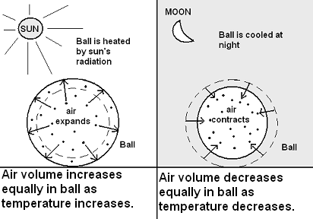
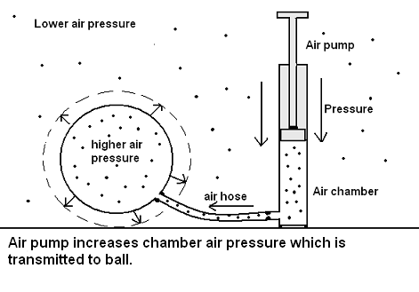
4.

3.
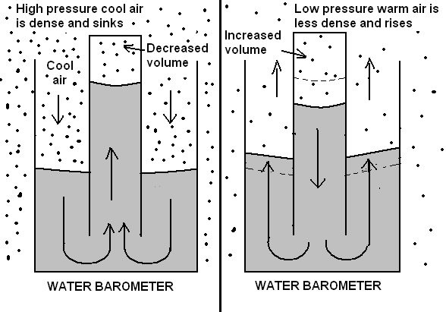
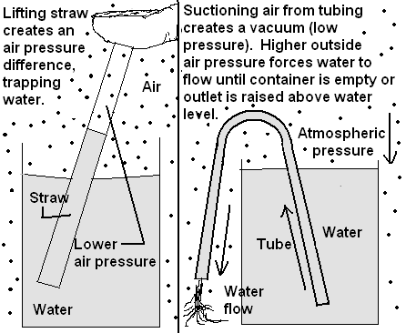

6.
5.
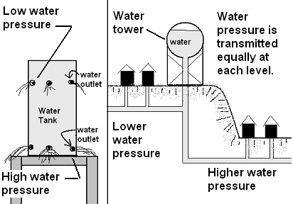
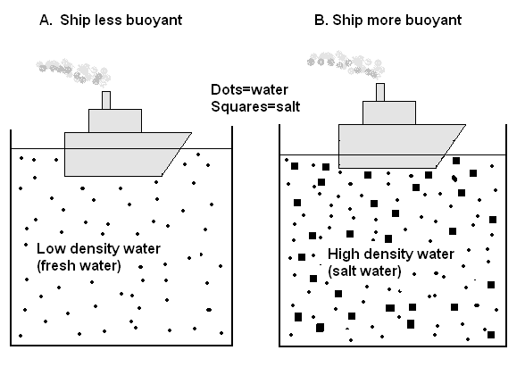
8..
7.

17.

